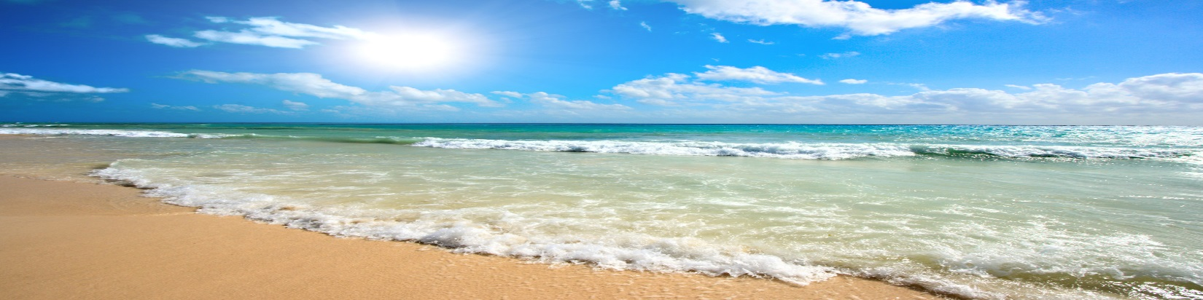
AAEOPP SPRING CONFERENCE
LIFE’S A BEACH!
Catch The TRIO Wave

Pensacola, Florida
April 22-25, 2018

2018 CALL FOR PROPOSALS
PRESENTATION TITLE:
(A separate form must be submitted for each workshop to be presented.)

Proposing a Workshop for Monday, April 23 and Tuesday, April 24 2018 Session Length: 75 minutes

(We may not able to guarantee your choice but will do our best to meet your preference.)

PRESENTER’S INFORMATION
Name: _________________________________ Position: _____________________________________________

Institution: ____________________________ Address: _____________________________________________

City: ___________________________ State: __________ Zip/Postal Code: _____________________________

Email: ______________________ Telephone: _______________________________________________

CO-PRESENTER’S INFORMATION

Name _________________________________ Position _______________________________

Institution: ____________________________ Address: ______________________________

City: _____________________ State: ______________ Zip/Postal Code: _________________

Email: ________________________________ Telephone: ( ) _______________________

TARGET AUDIENCE (Check all that apply)

All EOC ETS McNair UB UBMS SSS VUB GEARUP
All Administrative Support Coordinators Counselors Directors Other

ROOM SET-UP
Presenters are responsible for providing their own equipment (LCD projectors, laptops, etc,) and handouts. AAEOPP will not assume any responsibility for Audio Visual provisions.

NOTE: Prospective presenters MUST provide an Abstract or Session Description (in Microsoft Word; 100 words or less), for inclusion in the conference program.

Submit by email (scan) or fax no later than March 01, 2018 to:

Shawanda Marie Benjamin
sbenjamin@uab.edu
Office: 205-934-2729
Fax: 205-975-0369

